**Billing Management System**

**Table Of Content**

|  |  |
| --- | --- |
| **Sr.no** | **Description** |
| 1) | Problem Description |
| 2) | Requirements |
| 3) | Technologies |
| 4) | Use Case Diagrams |
| 5) | Class Diagram |
| 6) | Future Scope |

**Problem Statement:**

The objective is to make a platform where you can buy as well as sell your products. Now a days you have online sites where you visit and buy the products which you require but in this platform you can even sell your own products. This platform provides effective way of buying and selling to the customers.

**Features:**

* Customer can see new products in the Market.
* Customer can even become seller and sell his/her Products
* Customer will add the products which he/she wants to buy and will pay the required amount with which the bill will be generated.
* Bills are not mostly provided by Online shopping sites which is not the case of this platform
* This platform is not restricted to single type of product.

**Technologies**

**Frontend Technology:**

1. ATS
2. Swing
3. Netbeans IDE

**Backend Technology:**

1. JFrame

**Database: SQL**

**Use Case Diagram:**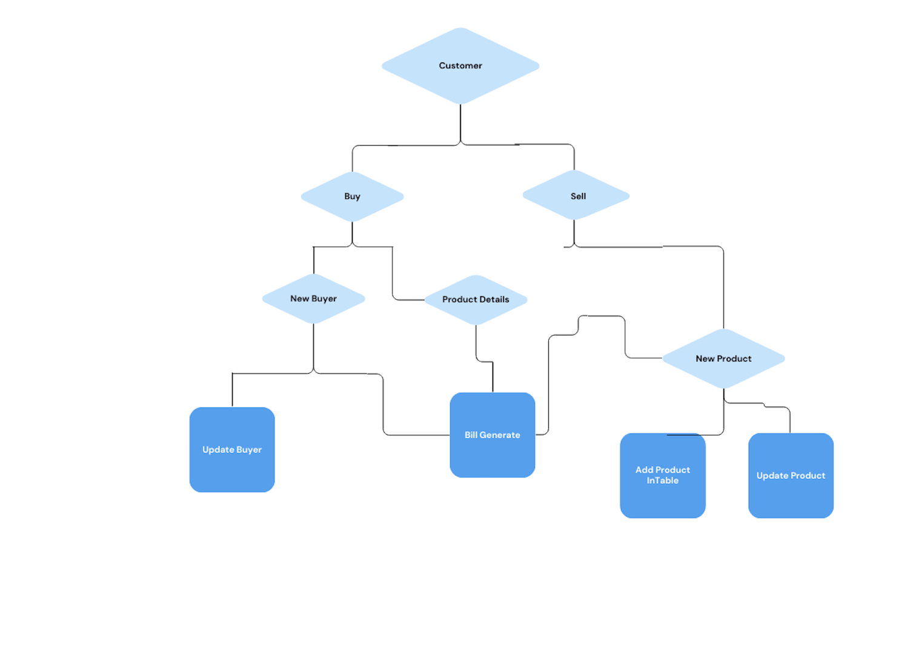

**Class Diagram:**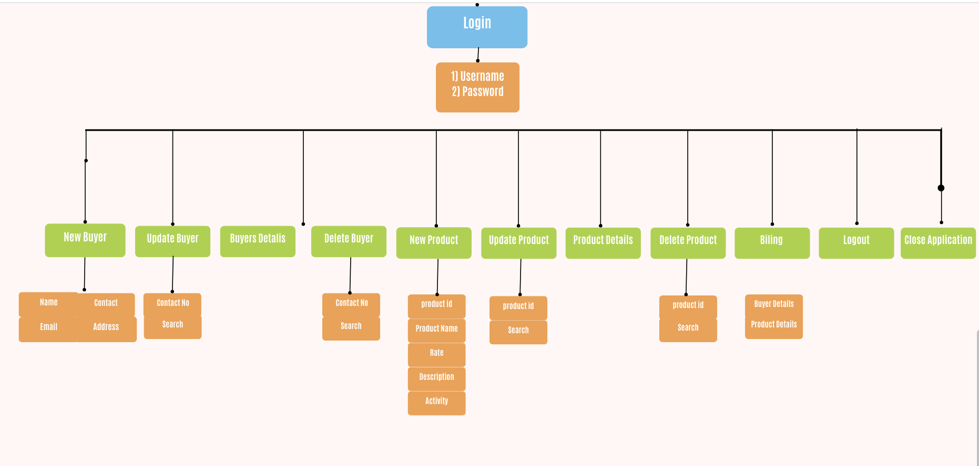

Future Scope

**Enhanced User Experience:**

Provides enhanced platform for both Buying and Selling of products.It will help the people who don’t have a proper platform to sell their products. This platform will give them all chance to sell their products which has no sell or have ratings are less.